User menu.

Open the tool:

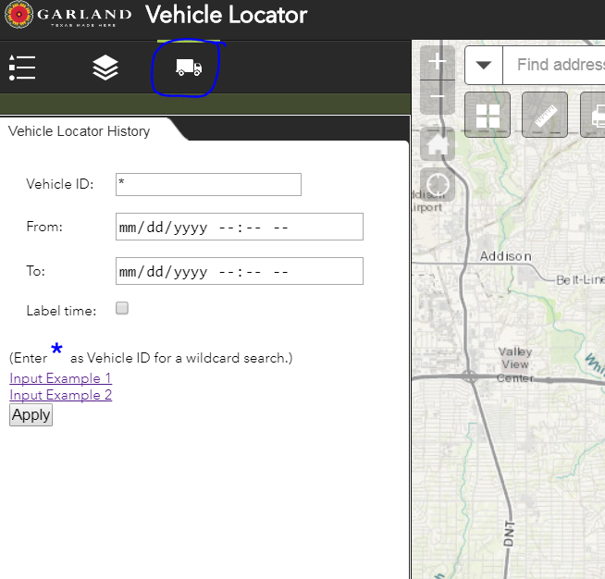

Search by vehicle and date, or search for all vehicles. Check the checkbox Label Time to label those dots by date and time.

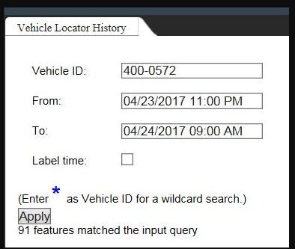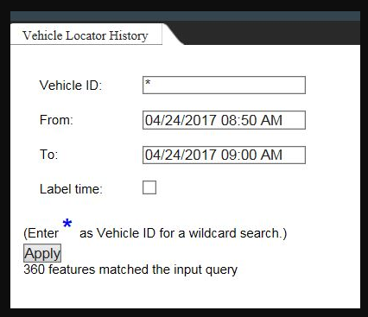

Click Apply.

Then results will show in the map as purple dots with a triangle inside. And the result layer will show up in the layer list. Click each purple dots to see the Vehicle ID and LocationDate.

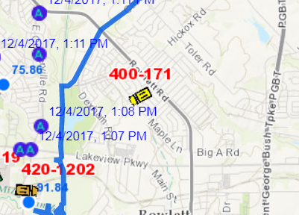 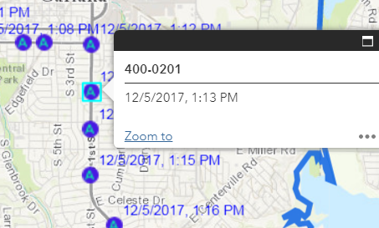 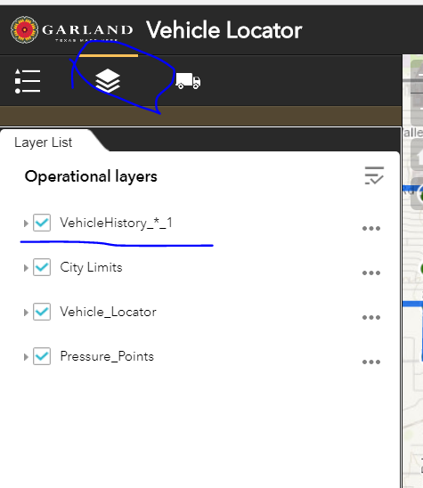

This tool can be run multiple time to add multiple results to the map. Each one shows up in the layer list as an individual layer, and represented by the same symbol. Click the checkbox to turn each one on and off.

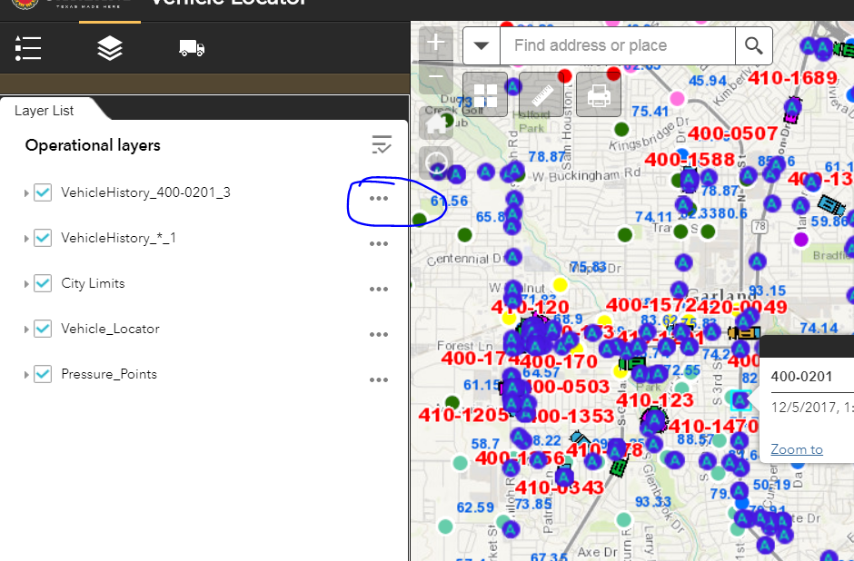

Click the three dots, get the layer menu. You will be able to turn labels on and off here.

